Module Code: CS3D5A
Module Name: Data Structures and Algorithms
Student Number:18315410
Student Name: Jintong Zhang

Assignment 4: Searching with Graphs

Goals:
1. Learn how to implement a graph, weighted and unweighted, directed and undirected
2. Become familiar and learn how to implement graph traversals
3. Learn how to implement Dijkstra and use it on a real-world example

Task 1: BFS and DFS

As for the graph representation, I use the adjacency matrix. Integers from 0 to 5 represent six vertexes which are A, B, C, D, E, and F. In this matrix, 0 means that there is not path between these two vertexes. On the other hand, 1 means there is a path.

The matrix is shown below.
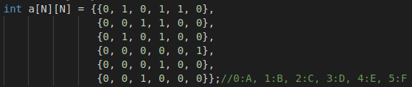
An adjacency matrix is easy to implement and understand, but when searching this method is not fast compared with adjacency lists. The time complexity of BFS and DFS using adjacency matrix are O(V^2). V means the number of vertexes. However, when using adjacency lists, time complexity is O(V+E). E means the number of edges.

The result of BFS is shown as followed.

The result of DFS is shown as followed.

Task 2: Dijkstra

In task 2, adjacency lists are implemented because it will save time when using Dijkstra algorithm. Because of the weight of each edge, a graph is made. It consists of every vertex and other adjacent vertex.

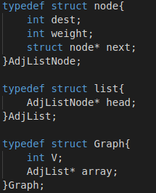

Dijkstra algorithm is based on BFS algorithm and updates the distance of adjacent vertexes. The only difference is that when using Dijkstra algorithm, we choose the vertex with shortest distance as next node.

To implement such algorithm, a min heap is made. Every time put the vertex with shortest distance as the root node and then extract it. Finally, we can make sure that distance of each node is shortest.

As for the time complexity, it is O((E+V)logV)

The output is shown below.

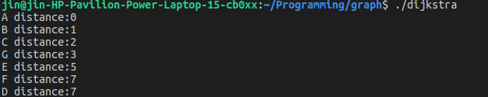
Task 3: On the buses

My task is to load the data from both files and use them to build a graph which models the public transport system of Dublin city. And then print the optimal sequence of bus stops from source to destination.

Firstly, I make a structure to store the edges read from “edges.csv” and then add these edges to a graph.
Secondly, I make another structure to record all the information about each bus stop read from “vertex.csv”. Finally, use the Dijkstra algorithm to calculate the shortest distance of each node and also record the path. When printing the result, I use a stack to print bus stops from departure place to destination.

The output is shown below.

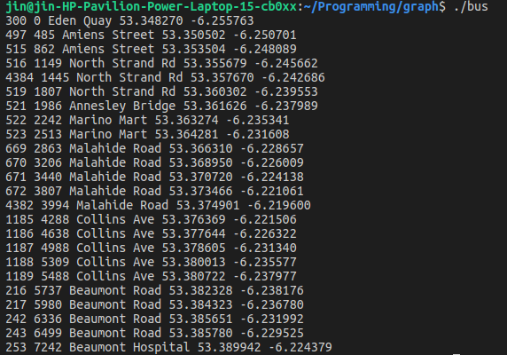
In the result, it contains stop ID, distance, name, latitude and longitude.

